Interview Record

Date: 18/09/2025

Interviewee: Mr Kentsenao Baseki

Interviewer: Ms Chenesani Wame Chikwakwa

Functional Requirements

|  |  |
| --- | --- |
| Question | Response |
| Who can open the accounts? | Any registered customer. Cheque accounts require proof of employment. |
| What types of accounts are available? | Savings, investment and cheque. |
| What are the rates for each account? | Savings: 0.05%monthly  Investment:5% monthly  Cheque: none. |
| Which conditions are required for opening each account? | Savings: none  Investments: minimum P500 deposit, Cheque: employer name and address. |
| What core customer details should be recorded? | Name, surname, ID, address, phone number, email. |
| What operations are allowed on each account? | Savings: deposit only  Investment: deposits and withdrawals, Cheque: deposits and withdrawals. |
| How should the system handle interest? | Automatically at month end. |
| Should customers be able to see balances and history? | Yes, for every account they hold, |
| Should the system require login? | Yes, customer must register and log in securely before accessing the accounts. |
| Can one customer have more than one account? | Yes, they can. |

Non-functional Requirements

|  |  |
| --- | --- |
| Question | Response |
| Should the system be easy to maintain and update? | Yes |
| Should it be user-friendly? | Yes, the interface should be simple and clear. |

Class Diagram

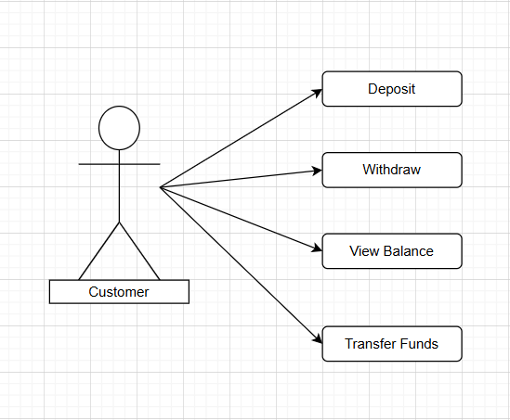

UML Diagram

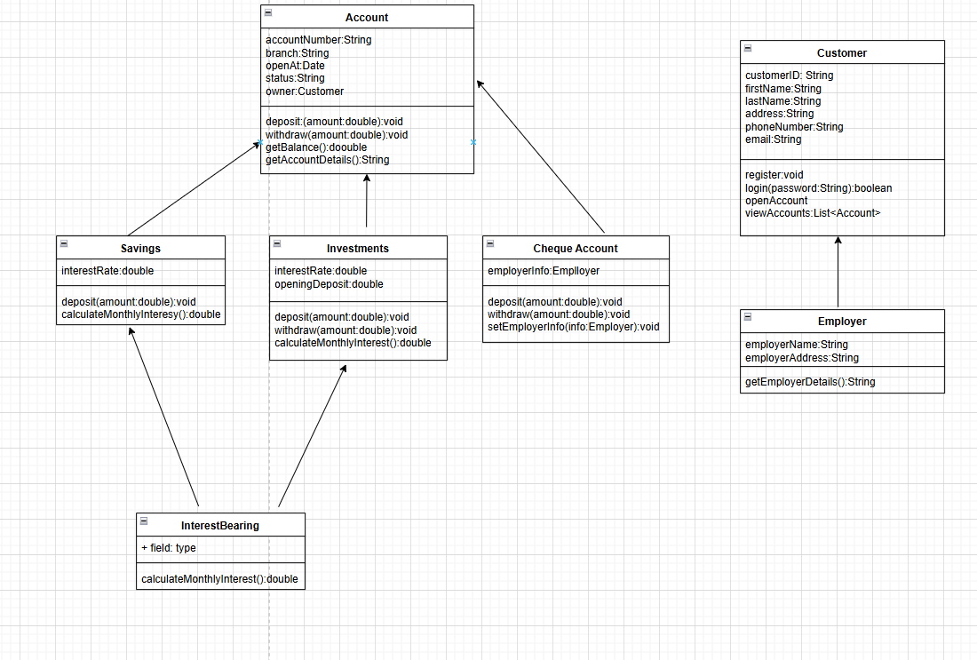

Login Sequence

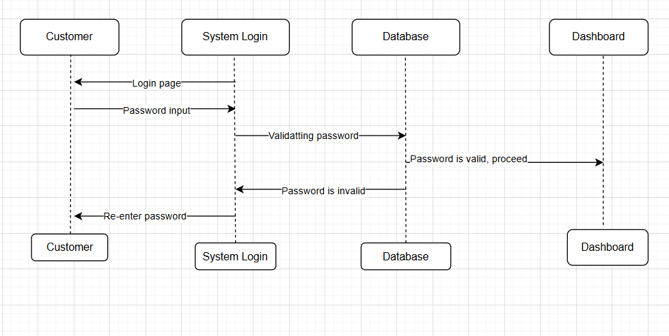

Deposit Sequence

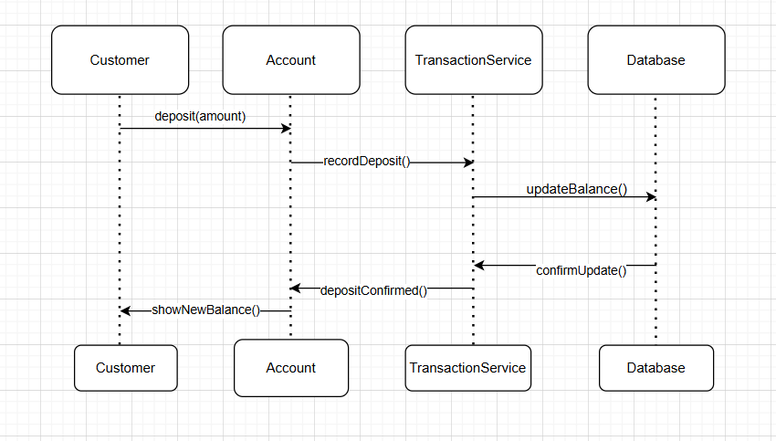

State Diagram

